

A Parent’s Introduction

Who is the Scout Troop for?
​ A Scout Troop is for young people aged from 10 ½ - 14 years old (6-month flexibility applies). Scouts meet together as a Troop and work within a variety of small groups called ‘Patrols’ lead by a Scout Patrol Leader.

The Patrol Leaders work with the Leadership Team in setting the programme and in decisions affecting the Troop. The Patrol system is one of the important ways that young people can take responsibility for themselves and others.

A volunteer leadership team made up of uniformed Leaders and other informal Assistants and helpers will guide the Troop.

Scouting has a reputation as an outdoor organisation based on strong traditions of camping and other outdoor pursuits.

Scouts work towards challenge awards, culminating in the Chief Scouts Gold Award. Scouts also have the opportunity to gain a wide range of activity badges by working inside and outside troop meetings. Most of the badges and awards in Scouts require independent work by the scouts themselves.

Most Troops will offer a number of events away from home during the year, and very often a summer camp. These are important to the life of the Troop, as they are the culmination of much of the training during the year.
Scout Uniform
​
Scouts wear:
- Green Scout Shirt
- Green Scout Hoodie – speak to the Leadership Team, only available through the Scout Group
- Shoes suitable for the event
These are available online for our County Scout Shop based in Middleton. The shop is open Mondays 7:00 PM – 9:00 PM or Saturdays 10:00 AM – 1:00 PM if your Scout needs to try on their uniform.
​
The Group necker will be given to your Scout when they are invested.
​​
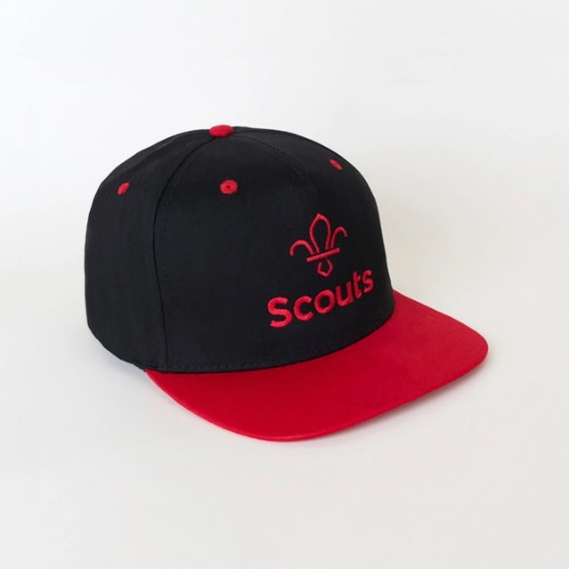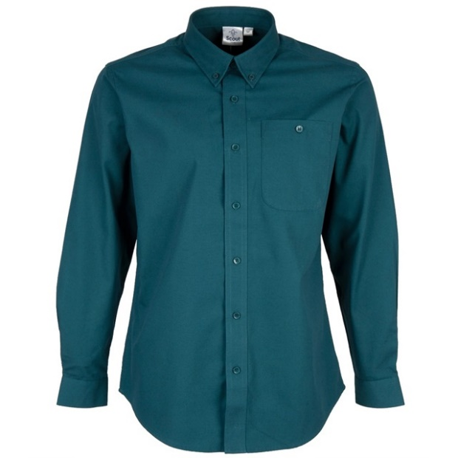​

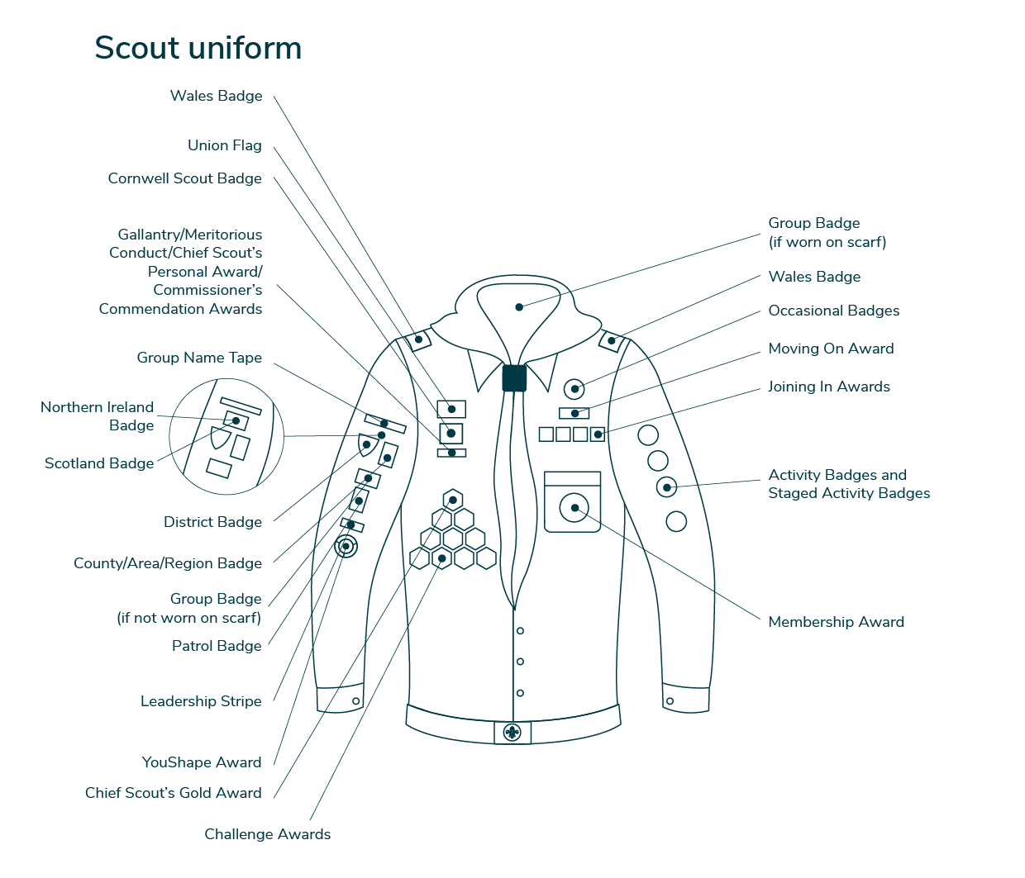
Camps
​
We arrange a Camp at least once a term, and a full Group camp every Summer. Please try and encourage them to attend as they really do enjoy it.
​
Badges
​
There are certain badges and awards that Scouts can gain whilst in the Section. These are:
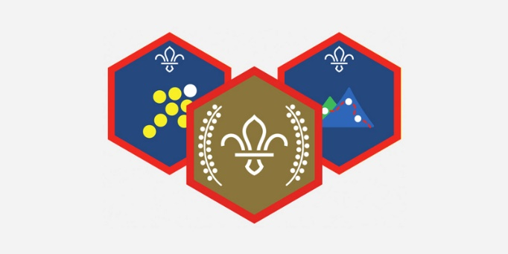
- Membership Badge – this is awarded when the Promise is made
- Challenge Awards
- Activity Badges
- Staged Badges
- Gold Chief Scout’s Award
- Moving-On Award
- Joining-In Award

Money
​
Scout Groups are run entirely by volunteers and are self-financing. On joining, each young person is required to pay a subscription to help cover the cost of premises, resources needed to run the activities and also the National Membership fee / activity insurance. Subs cost £15.00 per month.
​
We can make money if you complete the Gift Aid authorisation in OSM. The tax you have paid already on the monthly subscription can be claimed by the Group for the direct benefit of 3rd Chadderton Scouts.
​
Communications
​
We have a Facebook group called 3rd Chadderton Scouts, Cubs and Beavers. Please search for it and apply to be a member. We may also contact you via WhatsApp and email from OSM.
​
We post photos on the Facebook group of what we do during meetings and sleepovers. We will also let you know what we are doing at the meeting that evening.

​
How can you help?
​
The Scout who feels their parents and family are interested in and support their Scouting will achieve more. Support might be with fundraising, transport, or an offer to share a skill or hobby with other Scouts.

Please also show your support by attending the Annual General Metting (AGM). The ceremony normally takes place in the Summer and celebrates the best in local Scouting by giving trophies and certificates to the winners. Show your support to the Leaders by endorsing what they do.
​
Activities
​
Whatever activities the Scouts attend, they will need to be dressed appropriately for the activity. Strong Boots, a waterproof jacket and trousers are a great idea.
Leaders will need to have a contact number for you. Please ensure your personal details are up to date in OSM.
​
Parades
​
We are connected to St George's Church so we try to attend their parade services every second Sunday in the month. Please help us to support this. If there is an issue over attending the parades please speak to the Scout Team Leader.
​
Attendance
​
Please try to make sure your Scout comes to all meetings as we plan activities around gaining badges and not everything can be caught up. If your child is unable to attend, please let us know before the meeting.
Once a term begins, the Scouts will be asked to input ideas on what they’d like to do at their meetings.
If your child decides Scouts is not for them, then please tell us. It is important for us to know why a young person should not wish to come any more. If a young person leaves Scouts, they will not automatically be offered a place in Explorers. Scouts have a direct feed priority into Explorers.
If you are moving house to a different location, your Scout could be transferred to a nearer Group. Let us know, and we will complete a transfer to arrange this.

The Scout Promise
The Scout Promise for members who are atheist or of no faith background
On my honour,
I promise that I will do my best
to uphold our Scout values, to do my duty to The King,
to help other people
and to keep the Scout Law.
The Scout Promise for members who are Buddhist
On my honour,
I promise that I will do my best
to seek refuge in the Triple Gem, to do my duty to The King,
to act with compassion towards all life
and to keep the Scout Law.
The Scout Promise for members who are Christian
On my honour,
I promise that I will do my best
to do my duty to God and to The King,
to help other people
and to keep the Scout Law.
The Scout Promise for members who are Hindu
On my honour,
I promise that I will do my best
to follow my dharma and do my duty to The King,
to act with compassion towards all life
and to keep the Scout Law.
The Scout Promise for members who are Humanist
On my honour,
I promise that I will do my best
to uphold our Scout values, to do my duty to The King,
to help other people
and to keep the Scout Law.
The Scout Promise for members who are Jewish
On my honour,
I promise that I will do my best
to do my duty to God and to The King,
to help other people
and to keep the Scout Law.
The Scout Promise for members who are Muslim
In the name of Allah, the most beneficent and the most merciful,
I promise that I will do my best
to do my duty to Allah and then to The King,
to help other people
and to keep the Scout Law.
The Scout Promise for members who are Sikh
On my honour,
I promise that I will do my best
to do my duty to Waheguru and to The King,
to help other people
and to keep the Scout Law.

