

A Parent’s Introduction

Who is the Beaver Colony for?
​Beaver Scouts officially became members of The Scout Association in 1986 and have since gone from strength to strength, recently celebrating their 35th anniversary.

Beaver Scouting is for young people aged 6 and 8 years old.

Beavers is open to all who can make the Beaver Scout Promise.

There are different variants of the Promise depending on their beliefs – this is the Christian Promise:

I promise to do my best,
to be kind and helpful,
and to love God.

As a parent or guardian, you can be helpful by encouraging your child to learn these words or look for the alternatives promises (see below).

Beavers should try to understand what a promise is; then together, you can make this Promise become real.
Your child will need to have their uniform for the Promise ceremony which will be help after 3-4 weeks.
Beaver Uniform
​
Beavers wear:
- Turquoise Beaver sweatshirt
- Turquoise Beaver polo shirt
- Shoes suitable for the event
- Beaver cap
These are available online for our County Scout Shop based in Middleton. The shop is open Mondays 7:00 PM – 9:00 PM or Saturdays 10:00 AM – 1:00 PM if your Beaver needs to try on their uniform.
​
The Group necker will be given to your Beaver when they are invested.
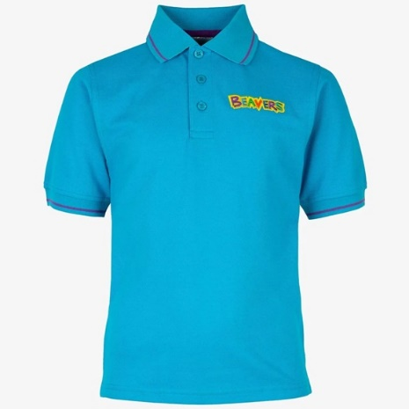
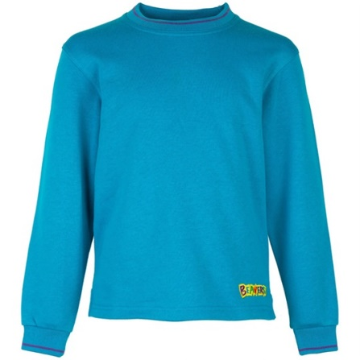
​​
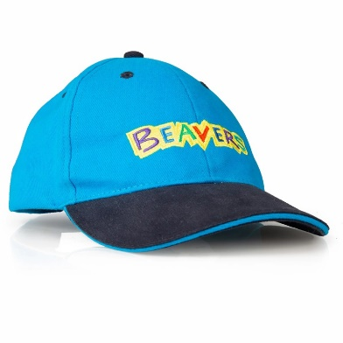
​

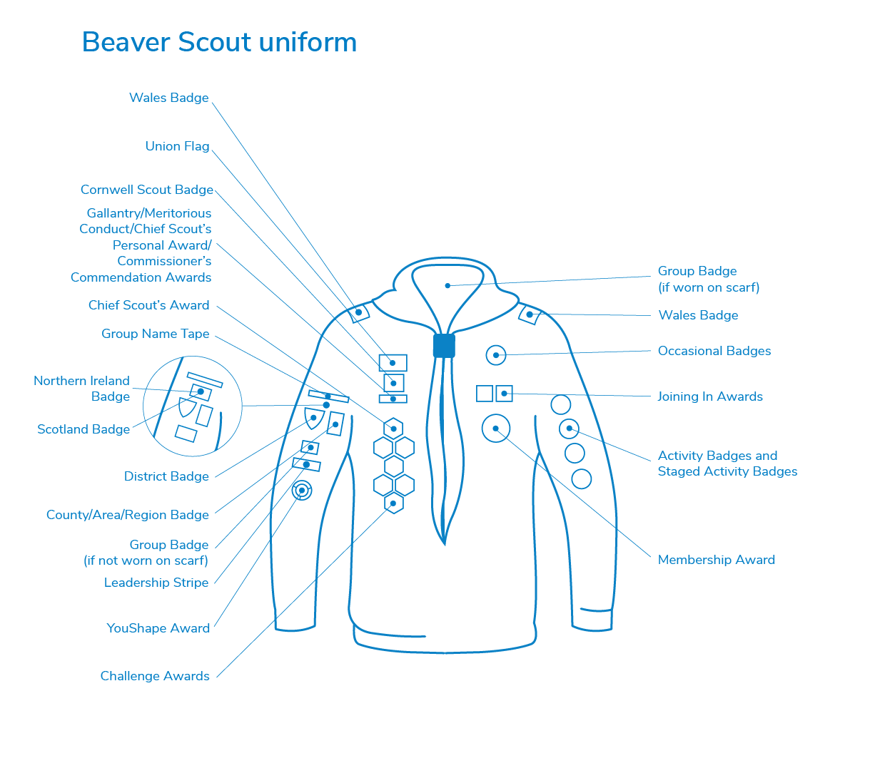
Who runs Beaver Meetings?
​
The Beaver Colony is run by people who freely give up their time to organise weekly activities for young people. The Leaders undergo training and receive support from other Team Members and Lead Volunteers locally. In addition to the Leaders, there are Skills Instructors, Assistants, Administrators, Trustee Board Members, fundraisers and so on. At 3rd Chadderton Scouts, we would very much welcome an offer of help from you. Why not speak to the Beaver Team Leader to see what you can do to help us?
​
What do Beavers do?
​Beaver Scouts usually meet once a week and take part in fun activities like making things, singing, playing games, going out on visits, investigating nature, listening to stories, learning how to be safe and, most importantly, making new friends.
​
Sometimes, having fun and playing games can be a bit noisy! Once your child has settled in and is part of the fun they won’t notice. When games finish and our activities begin, the noise level usually lowers but the fun continues.

Beaver Scouts are encouraged to contribute their ideas for Colony meetings and activities. Taking part in an active and balanced Colony programme is recognised by the presentation of the Beaver Scout badges.

Sleepovers
​
We arrange a sleepover at least once a term, with a full Group Camp every Summer. For some Beavers, this is the first time away from home. Please try and encourage them to attend as they really do enjoy it. From experience, it tends to be the parents that worry whilst the children are having a great time!
​
Badges
​
There are certain badges and awards that Beaver Scouts can gain whilst in the Section. These are:
- Membership Badge – this is awarded when the Promise is made
- Challenge Awards

- Activity Badges
- Staged Badges
- Bronze Chief Scout’s Award
- Moving-On Award
- Joining-In Award

Money
​
Scout Groups are run entirely by volunteers and are self-financing. On joining, each young person is required to pay a subscription to help cover the cost of premises, resources needed to run the activities and also the National Membership fee / activity insurance. Subs cost £15.00 per month.
​
We can make money if you complete the Gift Aid authorisation in OSM. The tax you have paid already on the monthly subscription can be claimed by the Group for the direct benefit of 3rd Chadderton Scouts.
​
Communications
​
We have a Facebook group called 3rd Chadderton Scouts, Cubs and Beavers. Please search for it and apply to be a member. We may also contact you via WhatsApp and email from OSM.
​
We post photos on the Facebook group of what we do during meetings and sleepovers. We will also let you know what we are doing at the meeting that evening.
​
How can you help?
​
The Beaver who feels their parents and family are interested in and support their Scouting will achieve more. Support might be with fundraising, transport, or an offer to share a skill or hobby with other Beavers.

Please also show your support by attending the Annual General Metting (AGM). The ceremony normally takes place in the Summer and celebrates the best in local Scouting by giving trophies and certificates to the winners. Show your support to the Leaders by endorsing what they do.
​
Activities
​
Whatever activities the Beavers attend, they will need to be dressed appropriately for the activity. Wellies, a waterproof jacket and trousers are a great idea.
Leaders will need to have a contact number for you. Please ensure your personal details are up to date in OSM.
​
Parades
​
We are connected to St George's Church so we try to attend their parade services every second Sunday in the month. Please help us to support this. If there is an issue over attending the parades please speak to the Beaver Team Leader.
​
Attendance
​
Please try to make sure your Beaver comes to all meetings as we plan activities around gaining badges and not everything can be caught up. If your child is unable to attend, please let us know before the meeting.
Once a term begins, the Beavers will be asked to input ideas on what they’d like to do at their meetings.
If your child decides Beaver Scouts is not for them, then please tell us. It is important for us to know why a young person should not wish to come any more. If a young person leaves Beavers, they will not automatically be offered a place in Cubs. Beavers have a direct feed priority into Cubs.
If you are moving house to a different location, your Beaver could be transferred to a nearer Group. Let us know, and we will complete a transfer to arrange this.

The Beaver Scout Promise
The Beaver Scout Promise for members who are atheist or of no faith background
I promise to do my best to be kind and helpful and to love our world.
The Beaver Scout Promise for members who are Buddhist
I promise to do my best to be kind and helpful and to act with love towards everyone.
The Beaver Scout Promise for members who are Christian
I promise to do my best to be kind and helpful and to love God.
The Beaver Scout Promise for members who are Hindu
I promise to do my best to be kind and helpful and to love the world.
The Beaver Scout Promise for members who are Humanist
I promise to do my best to be kind and helpful and to love our world.
The Beaver Scout Promise for members who are Jewish
I promise to do my best to be kind and helpful and to love God.
The Beaver Scout Promise for members who are Muslim
I promise to do my best to be kind and helpful and to love Allah
The Beaver Scout Promise for members who are Sikh
I promise to do my best to be kind and helpful and to love Waheguru.

