

A Parent’s Introduction

Who is the Cub Pack for?
​Cub Scouts officially became members of The Scout Association in 1916 and have since gone from strength to strength, the Section is based on the Jungle Book so all of the Volunteers in the Section have Jungle Book character names. The Cub Pack is led by the Leader of the Pack, Akela – as the leader of the wolf pack in the story.

Cubs is for young people aged 8 and 10 ½ years old.

Cubs is open to all who can make the Cub Scout Promise.

There are different variants of the Promise depending on their beliefs – this is the Christian Promise:

I promise to do my best,
to do my duty to God and The King,
to help other people, and to keep the Cub Scout Law

As a parent or guardian, you can be helpful by encouraging your child to learn these words or look for the alternatives promises (see below).

Your child will need to have their uniform for the Promise ceremony which will be help after 3-4 weeks.

Cub Uniform
​
Cubs wear:
- Green Cub sweatshirt
- Green Cub polo shirt
- Shoes suitable for the event
These are available online for our County Scout Shop based in Middleton. The shop is open Mondays 7:00 PM – 9:00 PM or Saturdays 10:00 AM – 1:00 PM if your Cub needs to try on their uniform.
​
The Group necker will be given to your Cub when they are invested.
​​
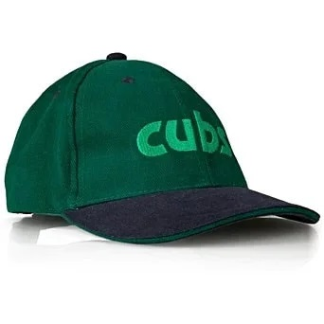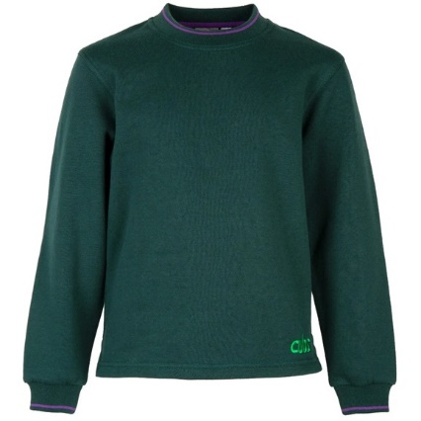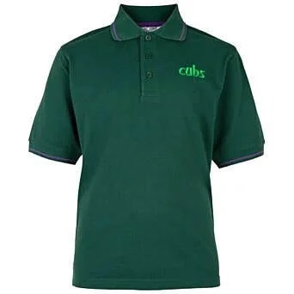​

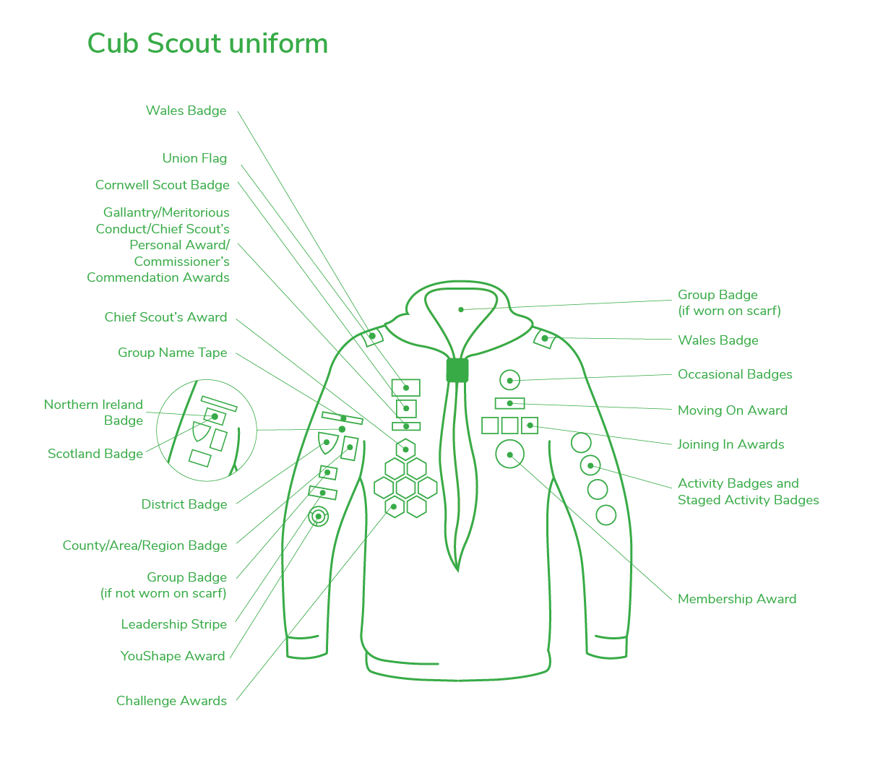
Who runs Cubs Meetings?
​
The Cub Pack is run by people who freely give up their time to organise weekly activities for young people. The Leaders undergo training and receive support from other Team Members and Lead Volunteers locally. In addition to the Leaders, there are Skills Instructors, Assistants, Administrators, Trustee Board Members, fundraisers and so on. At 3rd Chadderton Scouts, we would very much welcome an offer of help from you. Why not speak to the Cub Team Leader to see what you can do to help us?
​
What do Cubs do?
​ Cubs take part in a wide range of activities that are designed to be interesting and to challenge them. At the same time, they have fun, adventure and make friends along the way. They do this through taking part in a programme of activities provided by the Leadership team such as: camping, playing games, trying new things and exploring the outdoors.
Cub Scouts work towards awards and badges. The Cub Scout Membership Award is presented to new Cub Scouts once they have learnt about the traditions and history of Scouting and about being a Cub Scout today. Activity badges are specialist interest badges that can further develop a Cub Scout’s interest. They can also form the basis for special events and some are geared at the whole pack working together. With hard work and regular attendance Cub Scouts can gain their Chief Scout’s Silver Award, which is the highest award in the section.

Sleepovers
​
We arrange a sleepover at least once a term, and a full Group Camp every Summer. Please try and encourage them to attend as they really do enjoy it.
​
Badges
​
There are certain badges and awards that Cub Scouts can gain whilst in the Section. These are:
- Membership Badge – this is awarded when the Promise is made
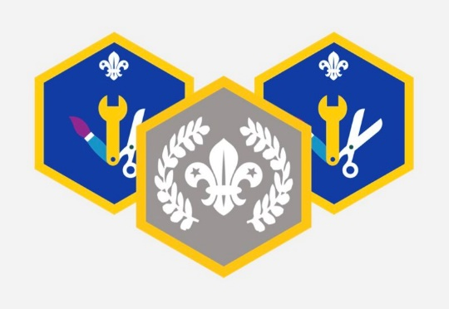
- Challenge Awards
- Activity Badges
- Staged Badges
- Silver Chief Scout’s Award
- Moving-On Award
- Joining-In Award

Money
​
Scout Groups are run entirely by volunteers and are self-financing. On joining, each young person is required to pay a subscription to help cover the cost of premises, resources needed to run the activities and also the National Membership fee / activity insurance. Subs cost £15.00 per month.
​
We can make money if you complete the Gift Aid authorisation in OSM. The tax you have paid already on the monthly subscription can be claimed by the Group for the direct benefit of 3rd Chadderton Scouts.
​
Communications
​
We have a Facebook group called 3rd Chadderton Scouts, Cubs and Beavers. Please search for it and apply to be a member. We may also contact you via WhatsApp and email from OSM.
​
We post photos on the Facebook group of what we do during meetings and sleepovers. We will also let you know what we are doing at the meeting that evening.
​
How can you help?
​
The Cub who feels their parents and family are interested in and support their Scouting will achieve more. Support might be with fundraising, transport, or an offer to share a skill or hobby with other Cubs.

Please also show your support by attending the Annual General Metting (AGM). The ceremony normally takes place in the Summer and celebrates the best in local Scouting by giving trophies and certificates to the winners. Show your support to the Leaders by endorsing what they do.
​
Activities
​
Whatever activities the Cubs attend, they will need to be dressed appropriately for the activity. Wellies, a waterproof jacket and trousers are a great idea.
Leaders will need to have a contact number for you. Please ensure your personal details are up to date in OSM.
​
Parades
​
We are connected to St George's Church so we try to attend their parade services every second Sunday in the month. Please help us to support this. If there is an issue over attending the parades please speak to the Cub Team Leader.
​
Attendance
​
Please try to make sure your Cub comes to all meetings as we plan activities around gaining badges and not everything can be caught up. If your child is unable to attend, please let us know before the meeting.
Once a term begins, the Cubs will be asked to input ideas on what they’d like to do at their meetings.
If your child decides Cubs is not for them, then please tell us. It is important for us to know why a young person should not wish to come any more. If a young person leaves Cubs, they will not automatically be offered a place in Scouts. Cubs have a direct feed priority into Scouts.
If you are moving house to a different location, your Cub could be transferred to a nearer Group. Let us know, and we will complete a transfer to arrange this.

The Cub Scout Promise
The Cub Scout Promise for members who are atheist or of no faith background
I promise that I will do my best
to uphold our Scout values, to do my duty to The King,
to help other people
and to keep the Cub Scout Law.
The Cub Scout Promise for members who are Buddhist
I promise that I will do my best
to seek refuge in the Triple Gem, to do my duty to The King,
to act with compassion towards all life
and to keep the Cub Scout Law.
The Cub Scout Promise for members who are Christian
I promise that I will do my best
to do my duty to God and to The King,
to help other people
and to keep the Cub Scout Law.
The Cub Scout Promise for members who are Hindu
I promise that I will do my best
to follow my dharma and do my duty to The King,
to act with compassion towards all life
and to keep the Cub Scout Law.
The Cub Scout Promise for members who are Humanist
I promise that I will do my best
to uphold our Scout values, to do my duty to The King,
to help other people
and to keep the Cub Scout Law.
The Cub Scout Promise for members who are Jewish
I promise that I will do my best
to do my duty to God and to The King,
to help other people
and to keep the Cub Scout Law.
The Cub Scout Promise for members who are Muslim
I promise that I will do my best
to do my duty to Allah and then to The King,
to help other people
and to keep the Cub Scout Law.
The Cub Scout Promise for members who are Sikh
I promise that I will do my best
to do my duty to Waheguru and to The King,
to help other people
and to keep the Cub Scout Law.

